Ethics of Collecting User Data in Modern Web Applications

Md. Rakibul Hassan
Department of Computer Science & Engineering
Bangladesh Army International University of Science & Technology (BAIUST)
Cumilla-3500, Bangladesh
rakibulhassanmiyaji27@gmail.com

Md. Tahsin Azad Shaikat
Department of Computer Science & Engineering
Bangladesh Army International University of Science & Technology (BAIUST)
Cumilla-3500, Bangladesh
tahsin.azad.skt@gmail.com

Mohammad Sakibul Hasan
Department of Computer Science & Engineering
Bangladesh Army International University of Science & Technology (BAIUST)
Chittagong-4100, Bangladesh
mohammadsakibbinnur@gmail.com

Muttakin Ahmed
Department of Computer Science & Engineering
Bangladesh Army International University of Science & Technology (BAIUST)
Cumilla-3500, Bangladesh
muttakinahmedsiam@gmail.com

Abstract—Modern web and mobile applications depend on personal data for analytics, personalization, advertising, and service improvement, yet the interfaces used to obtain consent may weaken user autonomy. This paper examines the engineering-ethics problem created by information asymmetry, manipulative consent design, technical opacity, and commercial pressure. We propose evaluating this problem through a bilingual user survey that identifies where consent interfaces fail to protect user autonomy and derives practical engineering principles to close that gap. A quantitative cross-sectional survey was implemented through a bilingual English–Bangla Google Form containing 26 closed-ended questions, and 154 valid responses were analyzed using frequencies, percentages, chi-square tests, and exploratory Spearman correlations. The results show that awareness alone does not guarantee meaningful consent: most respondents frequently encountered visually asymmetric consent banners and confusing privacy settings, yet strongly rejected unnecessary permission requests and supported stricter legal accountability. Ethical software engineering therefore requires balanced interfaces, data minimization, just-in-time permissions, and technical enforcement of users' choices.
Keywords—Engineering Ethics, User Privacy, Informed Consent, Dark Patterns, Web Applications

I. INTRODUCTION
Personal data has become a central input to modern web applications. Cookies, software development kits, analytics libraries, advertising networks, browser permissions, and cloud services can collect information about identity, location, interests, device characteristics, and online behavior. These mechanisms can improve functionality, but they also create ethical responsibilities for engineers who design data flows, user interfaces, and consent controls. The central issue is not merely whether a system displays an "Accept" button. It is whether users receive understandable information, can refuse without unreasonable effort, and can trust the software to enforce their decision.
The problem is intensified by unequal knowledge and power. Service providers understand their data pipelines, third-party integrations, and business incentives, while ordinary users usually see only a short notice or permission prompt. Bashir et al. [1] described this condition as information asymmetry and argued that limited comprehension and voluntariness can prevent genuine informed consent. Interface design can further shape outcomes. Controlled and large-scale studies have found hidden opt-out controls, visual asymmetry, preselected options, coercive permission rationales, and tracking that begins before users interact with a dialog [2], [3].
From an engineering-ethics perspective, these practices involve autonomy, privacy, fairness, transparency, non-maleficence, and professional accountability. Engineers may face pressure to maximize conversions or data collection, yet their professional duty includes protecting users from foreseeable harm and avoiding deceptive implementation. The ethical question is therefore both technical and behavioral: how should software be designed when users possess privacy concerns but operate under time pressure, cognitive load, and incomplete knowledge?
This paper is guided by five research questions: how much personal data a web application should reasonably collect, whether user consent alone is sufficient to make data collection ethical, how dark patterns shape users' privacy

decisions, what responsibilities software engineers hold when designing data-collection systems, and how companies can balance personalization with user privacy.
In this paper, we propose a survey-based engineering-ethics evaluation of user data collection practices that identifies where consent interfaces fail to protect user autonomy and derives practical design principles to close that gap. This study investigates the questions above through a survey of web and mobile-application users, reporting current user perceptions and self-reported behavior concerning consent, tracking, app permissions, trust, and regulation; comparing these patterns with empirical and conceptual findings from nine selected studies; and deriving practical engineering principles for consent interfaces and data-processing systems. The study does not claim to audit websites or prove causation; rather, it identifies reported patterns and exploratory associations that are ethically relevant to system design.

II. RELATED WORK AND RESEARCH GAP
A. Consent-Interface Compliance and Its Behavioral Effects
Nouwens et al. [2] examined 680 implementations of leading consent-management platforms and found that only 11.7% met minimum legal requirements for explicit consent, equal rejection effort, and the absence of pre-ticked boxes; their field experiment further showed that removing a rejection button increased consent by 22–23 percentage points. However, their experiment involved only 40 participants and focused solely on UK platforms, leaving open how ordinary users in other regions perceive and react to these same designs in daily use rather than in a controlled trial. Soe et al. [3] manually reviewed 300 news-site consent notices and found dark patterns in nearly all of them, but their analysis measured interface design directly rather than asking users how the friction affected their actual choices or trust. Our survey addresses this gap by asking respondents directly how often they encounter such asymmetric banners (66.2%) and whether that exposure changes their behavior, providing self-reported behavioral evidence that a design audit alone cannot capture.
B. Scale, Mobile Ecosystems, and the Limits of Automated Detection
Mathur et al. [4] crawled roughly 53,000 e-commerce pages and identified 1,818 dark-pattern instances along with 22 vendors selling manipulative-design services, demonstrating the practice is commercialized at scale. Their crawler, however, was limited to text-based patterns on shopping sites, meaning visual or interaction-based patterns and non-retail applications fell outside its detection. Koch et al. [5] extended this to mobile apps, finding that only 22.3% of sampled apps showed any consent dialog and that 94.2% of network requests occurred before any user interaction but their study measured technical traffic, not whether users were even aware this was happening. Nie et al. [6] confirmed a deeper problem: existing detection tools and datasets cover only 32 of 64 known dark-pattern types, a 50% gap, meaning automated tools alone cannot reliably protect users regardless of platform. These three studies together show that technical audits, however large in scale, cannot tell us what users themselves notice, understand, or tolerate, which is precisely what our survey measures instead: 84.4% of our respondents report being discouraged by confusing settings, and 36.4% remain unsure whether disabling a permission actually stops tracking, filling the perception-side gap that crawlers cannot.
C. Permission Rationales and Front-End Framing
Elbitar et al. [7] analyzed 770,000 web pages and found that overlays and full-screen permission rationales increased grant rates by 41% and 33% respectively, showing that framing alone can steer user decisions. Their study, however, measured grant rates, not whether users later recognized the framing as manipulative or regretted the decision, it captures the effect, not the user's own awareness of being influenced. Our survey closes this loop by directly asking whether users recognize manipulative intent behind such warnings: 47.4% interpreted "you may lose features" messages as an intentional fear-based tactic rather than a neutral explanation, connecting Elbitar's framing-effect data to actual user perception of manipulation.
D. Information Asymmetry and the Limits of Awareness
Bashir et al. [1] surveyed users at a single US institution and found major knowledge gaps about how cloud services and data brokers operate, arguing this undermines genuine informed consent. Bongard-Blanchy et al. [8] similarly found that 59% of a UK sample could recognize dark patterns in unbranded mockups, yet awareness did not predict resistance to manipulation. Both studies, however, were geographically limited to Western, English-speaking populations and used either abstract knowledge questions or unbranded design mockups rather than the respondent's own real, everyday app experience. Our study extends this line of work to a bilingual English–Bangla population, a demographic largely absent from existing dark-pattern research, and ties awareness directly to self-reported real-world behavior: 48.1% of our respondents admit accepting terms despite suspecting manipulation, reinforcing Bongard-Blanchy's awareness-resistance gap in a new cultural and linguistic context.
E. Ethical Frameworks Without Empirical Grounding
Simon et al. [9] provided a philosophical account of the tension between nudging and manipulation, arguing that ethical interfaces should treat users as rational, autonomous agents rather than exploit cognitive bias. This contribution is valuable but purely theoretical. It proposes no empirical test of whether real users actually want the choice-parity and transparency it recommends. Our survey provides that missing empirical support: 79.9% of respondents agree that rejection should be as easy as acceptance, and 87.7% support legal accountability for undisclosed data sharing, giving Simon's philosophical argument direct, measurable user backing.
The literature provides strong technical, experimental, and conceptual evidence, but most studies isolate a single dimension, such as cookie banners, mobile telemetry, permission rationales, or detection tools. There is comparatively limited evidence that examines privacy knowledge, perceived manipulation, permission behavior, trust, and regulatory expectations together within one bilingual user survey. The present study addresses this gap by integrating these dimensions in a single cross-sectional instrument and interpreting the results through engineering-ethics principles.

III. METHODOLOGY AND SURVEY IMPLEMENTATION
A. Research Design and Instrument
A quantitative, cross-sectional, descriptive, and exploratory survey design was used to capture user perceptions and self-reported behavior at a single point in time. This design was appropriate since the study aims to document current patterns of privacy concern and consent behavior rather than establish causal relationships. The target population consisted of individuals who use websites or mobile web applications, regardless of technical background, since the ethical concerns under investigation affect ordinary users rather than a specialized technical group.
Data were collected once through a bilingual English–Bangla Google Form containing 26 closed-ended questions, distributed through convenience sampling. A bilingual, closed-ended Google Form was selected over other instruments because it allowed rapid, low-cost distribution across a linguistically mixed population while keeping responses structured for frequency-based analysis. The survey covered three primary domains: respondent profile, including age group and daily web-application usage; privacy awareness, including concern about personal-data collection, tracking knowledge, and privacy-policy reading habits; and user behavior, including cookie choices, permission decisions, website avoidance, and convenience-based acceptance.
The form was distributed through accessible online networks from 13 to 19 July 2026. This represents non-probability convenience or snowball sampling rather than random sampling. A total of 154 valid submissions were obtained, with no missing responses across the 26 substantive items. The sample was strongly concentrated among younger users: 74.7% were aged 18–24, 19.5% were 25–34, 4.5% were 35 or older, and 1.3% were under 18. This age concentration likely reflects the digital channels used for distribution, which tend to reach younger users more readily than older populations. Consequently, the results should not be generalized to all internet users.
This section describes the design, implementation, and analytical approach used to investigate user perceptions of data collection ethics. It outlines the survey instrument, sampling method, and safeguards applied to protect respondent privacy throughout the study. The steps taken are described in sufficient detail to allow the study to be replicated or extended by future researchers.
TABLE I
SURVEY DOMAINS AND MEASURED VARIABLES
Survey domain | Questions | Main variables
Participant profile and usage | Q1–Q2 | Age group and daily web-application use
Privacy concern and consent | Q3–Q7, Q14 | Privacy concern, cookie choice, policy reading and convenience-based acceptance
Tracking knowledge and permissions | Q8–Q11, Q16–Q18 | Tracking knowledge, notification risks, permission behaviour and confidence that tracking stops
Interface design and friction | Q12–Q15 | Banner asymmetry, complicated settings, perceived manipulation and pressure warnings
Trust and regulation | Q19–Q26 | Trust, breach effects, accountability, equal rejection, stricter laws and satisfaction

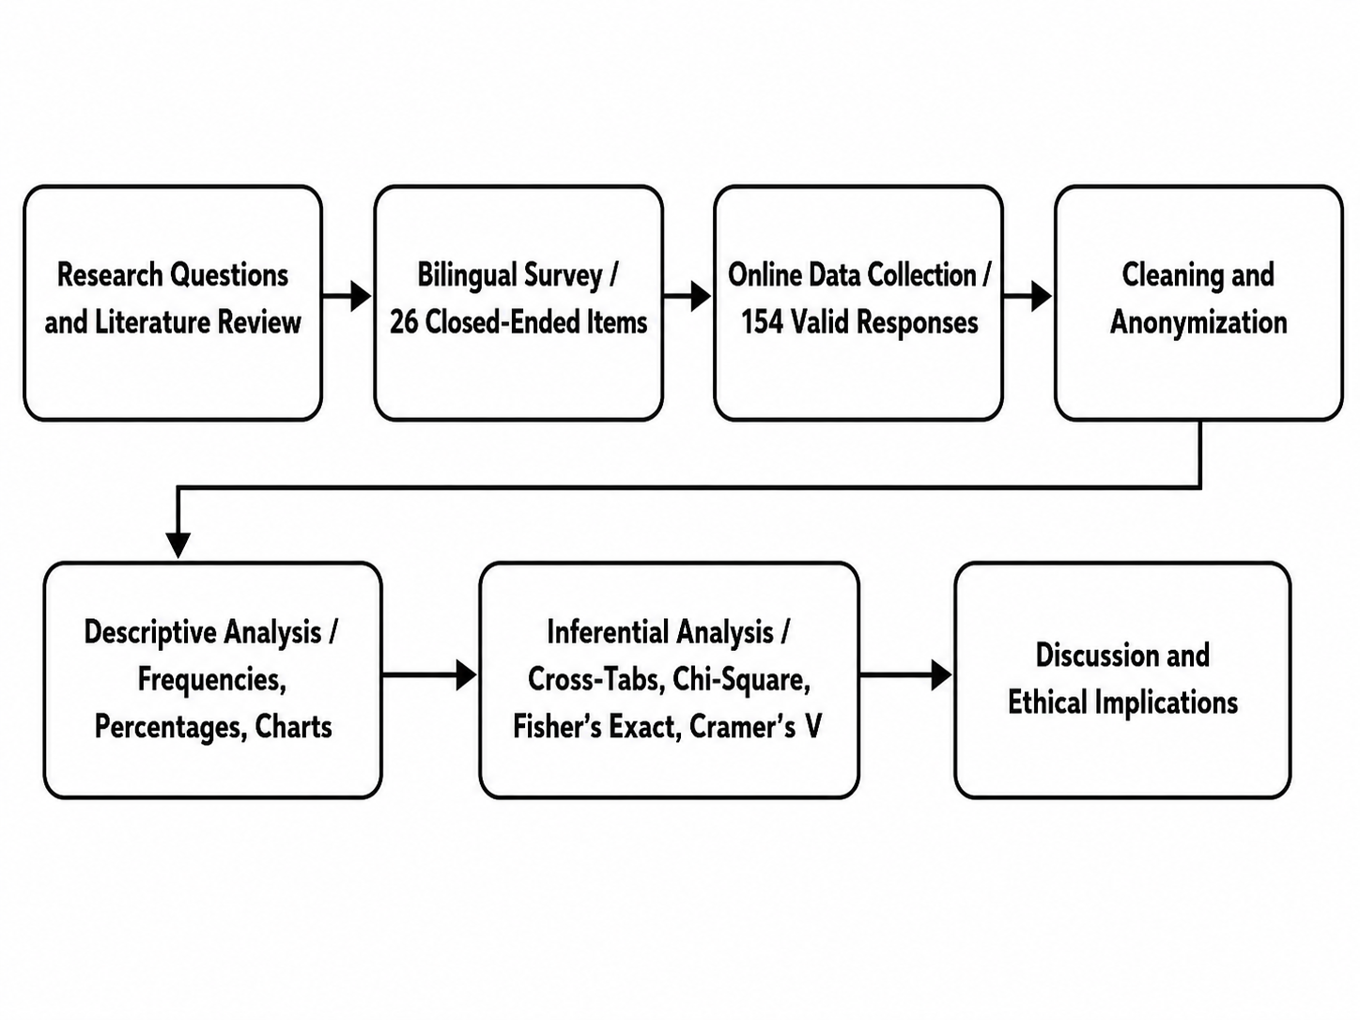
Fig. 1. Survey implementation and ethical-analysis workflow.
B. Data Preparation and Ethical Safeguards
The analytical process is summarized in Fig. 1. Responses were checked for completeness, duplicates, missing values, and inconsistent entries before analysis, and English–Bangla labels were standardized. Email addresses and other unnecessary identifiers were removed from the analytical copy, since personal identifiers were unnecessary for the research questions, and only aggregated findings were reported. This procedure reflects the same data-minimization principle that the study evaluates in software systems.
Participation was voluntary, and the study involved no experimental manipulation, source-code inspection, or network monitoring. The survey measured perceptions and self-reported choices. It therefore cannot establish that a particular interface caused behavior, determine whether a specific application violated law, or verify what occurred in background network traffic. These boundaries were maintained throughout the analysis.
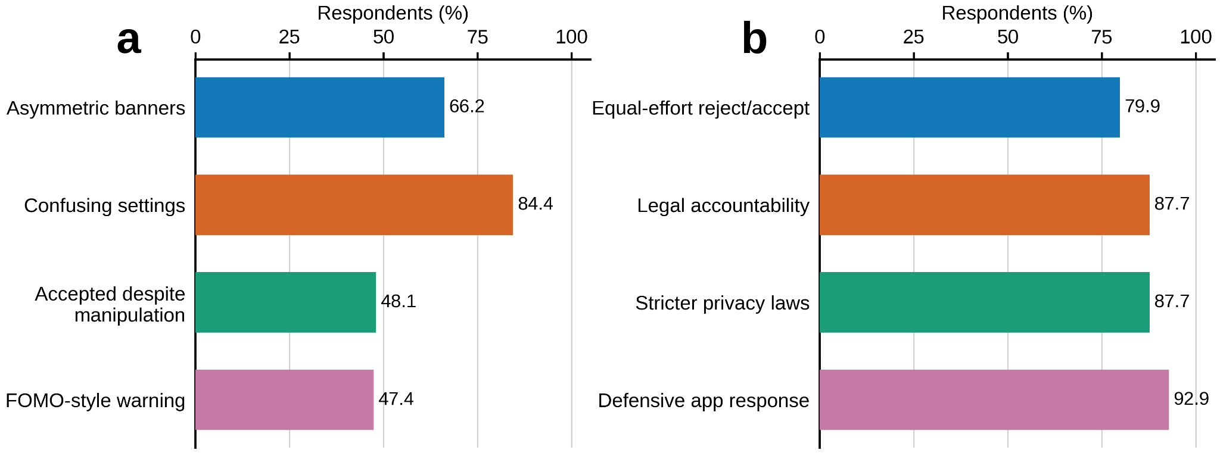
Fig. 2. (a) Reported exposure to manipulative interface patterns. (b) Support for regulatory and design accountability measures.
C. Descriptive and Statistical Analysis Strategy
The primary analysis used frequencies and percentages for all items, converted into descriptive charts to identify common behavioral and attitudinal patterns across three areas: consent behavior (acceptance, rejection, and avoidance patterns), interface experience (hidden rejection choices, confusing settings, and perceived manipulation), and trust and regulation (trust in technology companies and support for stronger privacy protection). Related categories were grouped only where the combination had a clear interpretation, such as "always" plus "often" for repeated exposure or "agree" plus "strongly agree" for policy support.
Cross-tabulations and chi-square tests of independence were used to examine relationships between categorical survey items, such as privacy concern and cookie-consent behavior, with Cramér's V reported as a measure of effect size. Exploratory Spearman rank correlations were used to examine relationships between ordinal variables, including privacy concern, tracking knowledge, consent behavior, interface experience, and trust. These tests were interpreted as associations rather than causal relationships, since the sample was non-probability based and the study was observational.
D. Reliability and Research Scope
Question wording, response-scale balance, and internal consistency were reviewed to reduce ambiguity, although the instrument was not validated as a formal psychometric scale. The findings are therefore limited by convenience sampling, concentration in the 18–24 age group, and reliance on self-reported rather than observed behavior.
E. Statistical Analysis
The anonymized dataset was analysed using jamovi. Frequencies and percentages were calculated for descriptive analysis, followed by cross-tabulations for five prespecified relationships. The expected frequency for cell i,j was calculated as
$E_{ij}=\frac{R_{i} C_{j}}{N}$ | (1)

where Rᵢ and Cⱼ are the corresponding row and column totals and N is the total number of observations. Pearson’s chi-square statistic was calculated as
$χ^{2}=∑_{i=1}^{r} ∑_{j=1}^{c} \frac{{(O_{ij}−E_{ij})}^{2}}{E_{ij}}$ | (2)
where Oᵢⱼ and Eᵢⱼ denote the observed and expected frequencies. The degrees of freedom for an r by c contingency table were determined by
$df=(r−1)(c−1)$ | (3)
All five analyses used 4 by 4 tables; therefore, the degrees of freedom were nine. Cramér’s V was used to quantify association strength because the contingency tables were larger than 2 by 2:
$V=\sqrt{\frac{χ^{2}}{N min(r−1,c−1)}}$ | (4)
Values near zero indicate weak association, while larger values indicate stronger association. Several tables contained expected frequencies below five. Fisher’s exact test with Monte Carlo simulation was therefore conducted as a sensitivity analysis. Statistical significance was initially evaluated at p < .05. Because five planned tests were performed, the Bonferroni-adjusted threshold was:
$α_{adjusted}=\frac{α}{m}=\frac{.05}{5}=.01$ | (5)
The analyses examined privacy concern and cookie behaviour, tracking knowledge and cookie behaviour, banner asymmetry and acceptance despite perceived manipulation, privacy-setting friction and acceptance, and trust in technology companies and privacy satisfaction. Results were interpreted as associations and not as evidence of causation.
F. Methodological Limitations
The non-probability sample and strong concentration of respondents aged 18–24 limit generalizability. Responses were self-reported and may differ from observed behaviour. The questionnaire was not established as a validated psychometric scale, and some items used uneven or conceptually complex response options. Moreover, the study did not technically verify whether particular applications transmitted data before consent, respected rejection choices, or violated privacy law.

IV. IMPLEMENTATION AND RESULTS
A. Respondent Profile
The majority of respondents were aged 18–24 (74.7%), with heavy daily application use: 50.6% reported 2–5 hours and 31.1% reported 6 or more hours of daily use, indicating a digitally engaged, young sample.
B. Privacy Awareness and Baseline Trust
Concern about personal-data collection was moderate to high: 49.4% reported being moderately or extremely worried, while 73.4% indicated at least some understanding of third-party tracking. Respondents were most sensitive about private photos/files (34.4%) and financial data (25.3%). Trust in technology companies was fragmented 38.3% mostly trusted them versus 31.2% who mostly distrusted them, and 86.4% said breach news had reduced their trust
C. Dark-Pattern Exposure and Interface Friction
As shown in Fig. 1, exposure to manipulative design was widespread: 66.2% often or always encountered visually asymmetric consent banners, and 84.5% had been discouraged from adjusting privacy settings by confusing interfaces. Even when aware of manipulation, 48.0% still clicked "Accept" to proceed, and 47.4% interpreted feature-loss warnings as a deliberate fear-based tactic rather than a technical explanation. A chi-square test confirmed a significant association between privacy concern and cookie-consent behavior (χ² = 27.9, df = 9, p < .001, Cramér's V = 0.246), indicating that more concerned respondents were more likely to actively seek a reject option.
D. App Permissions and Protective Behavior
Users were notably more assertive with app permissions than with cookie banners: 51.3% checked each permission individually, and 92.8% denied or deleted a flashlight app that requested contact access, as shown in Fig. 2. Still, confidence in system controls was limited, only 18.8% felt "very sure" that disabling a permission actually stopped tracking.
E. Regulatory Attitudes and Statistical Associations
Support for structural change was strong: 79.9% favored equal-effort reject/accept design, and 87.6–87.7% supported legal and governmental accountability for undisclosed data sharing (Fig. 2). Spearman rank correlations showed privacy concern was weakly associated with protective cookie behavior (ρ = 0.237, p = .003), dark-pattern exposure showed a weak negative association with quick-accept resistance (ρ = −0.157, p = .052), interface friction showed a similar weak negative association (ρ = −0.201, p = .012), and trust in technology companies was moderately associated with overall satisfaction (ρ = 0.499, p < .001). Tracking knowledge showed no meaningful association with cookie behavior (ρ = −0.012, p = .881), suggesting that awareness alone does not translate into protective action.
TABLE II
ASSOCIATIONS AMONG PRIVACY, CONSENT AND TRUST VARIABLES

Variables | χ² | df | Pearson p | Fisher p | Cramér’s V
Privacy concern × Cookie behaviour | 27.9 | 9 | <.001 | .001 | .246
Tracking knowledge × Cookie behaviour | 11.4 | 9 | .252 | .227 | .157
Banner asymmetry × Acceptance | 32.1 | 9 | <.001 | <.001 | .263
Privacy-setting friction × Acceptance | 32.9 | 9 | <.001 | <.001 | .267
Trust × Privacy satisfaction | 64.1 | 9 | <.001 | <.001 | .372

V. DISCUSSION AND ENGINEERING-ETHICS IMPLICATIONS
This section synthesizes the empirical survey data with existing literature to analyze the gap between privacy regulations (e.g., GDPR) and actual software implementations. Overall, the results matched expectations set by prior work: users report baseline privacy awareness, yet interface architecture, not awareness, appears to drive most consent outcomes. This pattern held consistently across every sub-theme tested.

A. Information Asymmetry in Data Collection
The survey highlights a structural information asymmetry between users and web applications, consistent with the framework proposed by Bashir et al. [1]. While 73.4% of respondents reported basic familiarity with third-party tracking, only 32.5% understood its technical mechanics. Furthermore, 36.4% of users remain uncertain whether system-level privacy toggles actually halt data transmission.
This uncertainty aligns with Koch et al.'s [5] findings on mobile telemetry, which showed tracking SDKs frequently transmit data before consent is given. Because background network requests are invisible to the average user, standard textual privacy policies fail to establish genuine informed consent, reflected here in the 42.2% of users who rarely or never read terms of service. This result matches, rather than contradicts, what Koch et al. found at the technical level: our respondents' self-reported uncertainty is the human-side mirror of the network-level opacity they measured directly.

B. Interface Asymmetry (Dark Patterns)
Asymmetric interface design significantly alters user behavior in our sample. A majority (66.2%) frequently encounter interfaces where "Accept All" is visually dominant while "Reject All" is hidden, and 26.0% click "Accept All" immediately just to bypass the barrier.
These findings empirically reinforce Nouwens et al. [2], who observed that consent-management platforms exploit visual asymmetry to stay within compliance loopholes while defeating their intent. Additionally, 84.5% of respondents have abandoned privacy settings or left an application due to complex, multi-layered menus, consistent with Soe et al. [3], who argued that platforms deliberately introduce friction to raise opt-out abandonment. Similarly, 47.4% of users interpret "you may lose features" warnings as intentional pressure rather than neutral information, echoing Elbitar et al. [7] and Nie et al. [6] on the systematic use of framing to steer permission decisions. Where our results differ slightly from the literature is in degree, not direction: our respondents report recognizing these tactics at notably higher rates than the general awareness levels Bongard-Blanchy et al. [8] found in their UK sample, suggesting either a more design-literate respondent pool or a genuinely higher exposure rate in this market.

C. Cognitive Load and the Privacy Paradox
The data shows a clear "privacy paradox": nearly half of respondents (48.0%) clicked "Accept" to proceed even while actively recognizing the interface as manipulative. This is explained by Bongard-Blanchy et al. [8], who argue that interaction friction and the desire for immediate access overwhelm baseline awareness, our result is directly in line with theirs, not an outlier.
Notably, this compliance is not blanket apathy. When context is explicitly violated. A flashlight app requesting contact-list access, 92.8% of users deny the permission or delete the app outright. This is the clearest point where our data goes beyond the literature: none of the nine reviewed studies tested a low-effort, high-clarity violation like this, so this result adds new evidence that users' privacy judgment is intact and functions correctly when the manipulation is obvious, the failure mode is specifically ambiguous, high-friction interfaces, not user carelessness in general.

D. System Engineering Implications
Respondents expressed strong demand for structural change: 79.9% support one-click parity between rejection and acceptance, and 87.6% support penalties for unnotified data sharing. This gives direct empirical backing to Simon et al.'s [9] purely theoretical argument that interfaces should treat users as rational agents, our data is the first of the reviewed literature to show that users themselves want exactly the design Simon et al. proposed on ethical grounds alone.
Based on both the literature and this evidence, ethical front-end engineering should adopt: visual parity (identical dimensions, contrast, and hierarchy for accept/reject controls), deterministic state handling (declining consent must immediately terminate third-party analytics instances), and just-in-time permissions (hardware access requested only at the moment of use, not preemptively).
This uncertainty aligns with Koch et al.'s [5] findings on mobile telemetry, which showed tracking SDKs frequently transmit data before consent is given. Because background network requests are invisible to the average user, standard textual privacy policies fail to establish genuine informed consent, reflected here in the 42.2% of users who rarely or never read terms of service. This result matches, rather than contradicts, what Koch et al. found at the technical level: our respondents' self-reported uncertainty is the human-side mirror of the network-level opacity they measured directly.

VIII. CONCLUSION AND FUTURE WORK
This paper examined the ethics of user-data collection through a bilingual survey of 154 web and mobile-application users, addressing the imbalance of power between service providers and users created by asymmetric consent interfaces. The findings show that awareness alone does not guarantee meaningful consent: respondents reported substantial privacy concern and frequent exposure to dark-pattern-style banners, yet convenience often overrode their stated preferences, while clearly unnecessary permission requests produced strong, consistent resistance. These results indicate that ethical data collection requires more than a legally compliant notice; it requires balanced interface design, data minimization, just-in-time permissions, and technical enforcement of the choices users actually make.
With additional time and resources, this study could be extended through controlled A/B experiments comparing symmetric and asymmetric consent banners, along with technical audits of network requests before consent and after rejection. A larger, probability-based sample with broader age, education, and regional representation would improve generalizability beyond the present convenience sample, and the survey instrument itself should be piloted and validated for reliability in future work.
REFERENCES
[1] M. Bashir, C. Hayes, A. D. Lambert, and J. P. Kesan, "Online privacy and informed consent: The dilemma of information asymmetry," Proc. Association for Information Science and Technology, vol. 52, no. 1, pp. 1–10, 2015, doi: 10.1002/pra2.2015.145052010043.
[2] M. Nouwens, I. Liccardi, M. Veale, D. Karger, and L. Kagal, "Dark patterns post-GDPR: Scraping consent interface designs and demonstrating their influence," in Proc. CHI Conf. Human Factors in Computing Systems, 2020, pp. 1–13, doi: 10.1145/3313831.3376321.
[3] T. H. Soe, O. E. Nordberg, F. Guribye, and M. Slavkovik, "Circumvention by design: Dark patterns in cookie consent for online news outlets," in Proc. 11th Nordic Conf. Human-Computer Interaction, 2020, pp. 1–12, doi: 10.1145/3419249.3420132.
[4] A. Mathur, G. Acar, M. J. Friedman, E. Lucherini, J. Mayer, M. Chetty, and A. Narayanan, "Dark patterns at scale: Findings from a crawl of 11K shopping websites," Proc. ACM Human-Computer Interaction, vol. 3, no. CSCW, Art. no. 81, pp. 1–32, 2019, doi: 10.1145/3359183.
[5] S. Koch, B. Altpeter, and M. Johns, "The OK is not enough: A large scale study of consent dialogs in smartphone applications," in Proc. 32nd USENIX Security Symp., 2023, pp. 5467–5484.
[6] L. Nie, Y. Zhao, C. Li, X. Luo, and Y. Liu, "Shadows in the interface: A comprehensive study on dark patterns," Proc. ACM Software Engineering, vol. 1, no. FSE, Art. no. 10, pp. 1–22, 2024, doi: 10.1145/3643736.
[7] Y. Elbitar, S. Khodayari, M. Harbach, G. De Stefano, B. C. Engedy, G. Pellegrino, and S. Bugiel, "Permission rationales in the web ecosystem: An exploration of rationale text and design patterns," in Proc. CHI Conf. Human Factors in Computing Systems, 2025, pp. 1–25, doi: 10.1145/3706598.3713547.
[8] K. Bongard-Blanchy, A. Rossi, S. Rivas, S. Doublet, V. Koenig, and G. Lenzini, "I am definitely manipulated, even when I am aware of it. It's ridiculous!: Dark patterns from the end-user perspective," in Proc. Designing Interactive Systems Conf., 2021, pp. 763–776, doi: 10.1145/3461778.3462086.
[9] M.-S. Simon, H. Schraffenberger, and R. Gellert, "Influencing user decisions: Dilemmas in designing online interfaces," in Adjunct Proc. Nordic Conf. Human-Computer Interaction, 2024, pp. 1–6, doi: 10.1145/3677045.3685441.

